A PROJECT REPORT

ON

**EMOTION AND ACTIVITY BASED MUSIC PLAYER**

SUBMITTED TO THE SAVITRIBAI PHULE PUNE UNIVERSITY,PUNE

IN THE PARTIAL FULFILLMENT FOR THE AWARD OF THE DEGREE

OF

**"BACHELOR OF ENGINEERING IN INFORMATION TECHNOLOGY"**

BY

**Arya Joshi B400530636**

**Dnyaneshwari Dhumal B400530618**

**Akanksha Ghadge B400530624**

**Abhimanyu Giri B400530626**

###### UNDER THE GUIDANCE OF

**Prof. Balaji Chaugule**



**DEPARTMENT OF INFORMATION TECHNOLOGY**

**ZEAL EDUCATION SOCIETY’S**

**ZEAL COLLEGE OF ENGINEERING RESEARCH NARHE, PUNE 411041**

**2024-2025**



**CERTIFICATE**

**This is to certify that the project report entitled "Emotion and Activity**

**Based Music player”**

**SUBMITTED BY**

**Arya Joshi B400530636**

**Dnyaneshwari Dhumal B400530618**

**Akanksha Ghadge B400530624**

**Abhimanyu Giri B400530626**

The work carried out by them under the supervision of Prof. Balaji Chaugule and it is approved for the partial fulfilment of the requirement of Savitribai Phule Pune University for the award of the Degree of Bachelor of Engineering (Information Technology).

This Project report has not been earlier submitted to any other Institute or University for the award of any degree or diploma.

Prof. Balaji Chaugule Prof. Balaji Chaugule

Internal Guide Head of Department

External Examiner Dr.A.M.Kate

Date: Principal

Place: Zeal College Of Engg. and Research

**ACKNOWLEDGEMENT**

It gives us immense pleasure to present this document report on the Project Work undertaken during the BE Final Year. We sincerely acknowledge and offer our gratitude to all who have directly or indirectly supported this project.

First and foremost, we wish to express our deep sense of gratitude and gratefulness to our guide Mr. Balaji Chaugule (**Department of Information Technology)** for his inspiring guidance, constructive criticism, and valuable suggestion throughout this project.

We owe a special debt of gratitude to our Project Coordinator **Prof. Amol Jadhav (Department of Information Technology)**, for his constant support, encouragement, and management throughout the course of our work.

We would like to thank Head of the Department, **Mr. Balaji Chaugule,** who have been cooperative throughout this year for providing enough sources of requirements and peaceful atmosphere in the department for the completion of this project.

We would like to extend our profound gratitude towards our Principal, **Dr. Ajit M. Kate, Zeal College of Engineering and Research, Narhe, Pune** and the management for providing us all the infrastructure in the department to complete our work without any huddles and obstacles.

We would like to heartfully thank **our parents and siblings** for encouraging us in all of our pursuits and inspiring us to acquire our dreams. We are especially grateful to our parents, who supported us emotionally and financially. They always knew and believed in us to get the best from us in the entire 4 years of Engineering journey.

Finally, we would like to extend our gratitude to all **our friends** who have always encouraged and supported us in completing this project work.

**ABSTRACT**

Music plays an important role in our everyday lives. It can lift our mood, help us concentrate, or simply make a moment more enjoyable. People often choose different songs depending on what they’re doing or how they’re feeling. This project focuses on creating a smart music player that can detect a user’s current activity (such as running, walking, or resting) and emotional state (like happy, sad, or stressed), then play songs that match those conditions.

To achieve this, the system gathers data from wearable gadgets like fitness bands or smartwatches to identify the user’s activity. For emotion detection, it analyzes facial expressions, voice tone, or even text messages typed by the user. Using machine learning models, the system processes this information to recognize the user’s activity and mood in real time.

Once the system knows the user’s current state, it selects suitable songs from a music library and plays them automatically. This creates a smooth and personalized listening experience without the need for manual song selection.

The project uses Python along with machine learning libraries like TensorFlow and Keras. The mobile application is developed using Android or Flutter, and user data—such as preferences and listening history—is stored in cloud services like Firebase. Overall, this intelligent music player offers a unique and customized music experience by adapting to the user’s emotions and activities

**INDEX**

1. Introduction 1
   1. Overview . . . . . . . . . . . . . . . . . . . . . . . . . . . . . . . 2
      1. Motivation . . . . . . . . . . . . . . . . . . . . . . . . . . 2
      2. Objective . . . . . . . . . . . . . . . . . . . . . . . . . . . 2
2. Literature Survey 3
   1. Study Of Research Paper . . . . . . . . . . . . . . . . . . . . . . . 3
3. Problem Statement 10
   1. Problem Statement 10
4. Project Requirement 11
   1. EXTERNAL INTERFACE REQUIREMENT 11
      1. User Interface 12
      2. Hardware Interfaces 12
      3. Software Interfaces 12
   2. NON FUNCTIONAL REQUIREMENT 11
      1. Performance Requirements 11
      2. Safety Requirement 12
      3. Software Quality Attributes 13
5. System Design 14
   1. System Architecture 14
      1. Module 15
      2. Data Flow Diagram 17
   2. UML DIAGRAMS 18
6. System implementation 22
   1. Methodology (SVM) 25
   2. System Implementation Plan 25
7. Result And Evaluation 29
   1. Results 26
   2. Outputs ………………………………………… 26
   3. Conclusion ………………………………………………………. 31
8. References 39
9. Appendix A 40
10. Appendix B 41
11. Appendix C 42

* 1. System Architecture 15
  2. Data Flow(0) diagram 18
  3. Data Flow(1) diagram 18
  4. Data Flow(2) diagram 18
  5. Class Diagram 19
  6. Use case Diagram 20
  7. Sequence Diagram 21
  8. Activity Diagram 22
  9. Comparisn of Existing system and Implemented System……………………………………32
  10. Publication Detail…………………………………………………………………………… 38
  11. Detailed Test Cases ……………………………………………………………………………41

# CHAPTER-1

## INTRODUCTION

### Introduction :

Music has a strong influence on our daily lives. It can improve our mood, help us concentrate, boost energy during exercise, or relax us when we’re feeling overwhelmed. People usually pick songs that reflect how they feel or what they’re doing—for instance, playing energetic tracks while running or soothing music when winding down for sleep. But having to choose songs manually each time can be time-consuming, especially when someone is busy or unsure of what to play.

To solve this, the proposed project aims to develop a smart music player that automatically adjusts to the user’s current physical activity (like sitting, walking, or running) and emotional state (such as happy, relaxed, stressed, or sad). Using machine learning, the system detects these conditions and plays songs that match, creating a smooth and customized music experience.

The system collects input data from different sources. To recognize physical activity, it can use motion sensors like accelerometers and gyroscopes found in smartphones or wearable devices. For detecting emotions, it may rely on analyzing facial expressions through a camera, voice pitch through a microphone, or even the content of text messages typed by the user. All this data is processed by machine learning models trained to classify various emotions and physical states.

Once the current mood and activity are identified, the music recommendation system selects appropriate tracks from a library. It chooses songs based on features such as mood labels, tempo, music genre, and lyrics. For instance, if the user is relaxing, the player may choose gentle instrumental music. If the user is feeling cheerful and jogging, it might suggest high-energy songs to maintain enthusiasm. This real-time response makes the music player intelligent, adaptive, and more enjoyable for everyday use.

###### OVERVIEW

In the modern digital age, music has become a crucial part of daily life, offering emotional support, motivation, and relaxation. However, the traditional method of manually selecting songs does not always align with the listener’s real-time feelings or physical context. To address this, the proposed project introduces an intelligent music player designed to adapt dynamically to a user's emotional state and physical activity using machine learning techniques.

The system functions by collecting data from various input sources—such as motion sensors (e.g., accelerometers and gyroscopes in smartphones or wearables) to identify activities like walking, running, or resting, and emotion-detection mechanisms including facial expression analysis via camera, voice tone analysis through a microphone, or sentiment interpretation from typed text.

These diverse inputs are processed in real time by machine learning models (developed using Python and TensorFlow), which are trained to recognize distinct emotional and physical states. Once the system classifies the user’s current mood and activity, it uses a personalized recommendation engine to select music that resonates with the user’s context—whether it’s calming music for a relaxed mood or high-tempo beats for workout sessions.

The music player not only enhances user experience by reducing the need for manual intervention but also ensures continuous emotional engagement and contextual relevance. Its goal is to provide a seamless, adaptive, and personalized music journey that evolves with the user throughout the day.

* 1. **Motivation**

Music is deeply intertwined with human emotions and daily routines—it uplifts moods, enhances focus, energizes workouts, and soothes stress. Often, individuals choose songs that resonate with their current emotional state or the activity they are engaged in. However, manually browsing and selecting songs every time a mood changes or an activity shifts can be both tedious and distracting, particularly in fast-paced or emotionally charged situations.

This project is inspired by the desire to make music interaction more seamless and context-aware. The goal is to harness the power of machine learning to create a smart music system that intuitively understands how a user feels or what they’re doing and responds by playing music that complements or improves that state. By automating this process, the system not only saves time but also enhances emotional well-being, focus, and user satisfaction.

Whether a user is running, relaxing, feeling cheerful, or overwhelmed, the system aims to be their personalized musical companion—offering the right sound at the right moment without any manual input.

* 1. **Objective**
     + **Emotion Detection** – Identify user emotions using facial expressions, voice, or physiological signals.
     + **Activity Recognition** – Detect current user activity (e.g., running, studying, relaxing) via sensors or input.
     + **Personalized Playlist Generation** – Curate music playlists that match the detected emotion and activity.
     + **Seamless User Experience** – Offer an intuitive and interactive UI for easy control and feedback.
     + **Real-Time Adaptation** – Dynamically change music based on shifts in emotion or activity.

# CHAPTER 2

## LITERATURE SURVEY

###### STUDY OF RESEARCH PAPER

1. **Paper Name: Emotion Based Music Player**

**Author: Krittrin Chankuptarat and Raphatsak Sriwatanaworachai**

**Abstract** : The study titled *"Emotion-Based Music Player"* by Krittrin Chankuptarat and Raphatsak Sriwatanaworachai presents an innovative Android application that recommends music based on the user’s emotional state. Rather than requiring users to browse or manually select songs that suit their mood, this app simplifies the process by automatically detecting how they feel.

The app determines the user’s emotions through two main inputs: heart rate and facial expressions. It analyzes heart rate data to assess whether the person is calm, stressed, or excited, and uses Google’s Face API to interpret facial cues such as smiles or frowns. After identifying the user’s emotional state—whether it's happiness, sadness, or relaxation—the system suggests music that fits the mood. It also considers the user’s music preferences and past listening behavior for better recommendations.

This approach creates a more engaging and personalized music experience, offering songs that resonate emotionally with the user at any given moment.

1. **Paper Name: : Smart Music Player based on Facial Emotion Author: M. Srinayani, P. Naga Jahnavi, and S. Kavishree**

**Abstract** : In the paper *"Smart Music Player Based on Facial Emotion"* by M. Srinayani, P. Naga Jahnavi, and S. Kavishree, the authors present a music system that personalizes your listening experience by analyzing your facial expressions. The goal is to create a deeper emotional connection between the listener and the music by automatically adjusting song choices to match the user’s current mood.

In a world where many people regularly experience stress, anxiety, or emotional fluctuations, this technology offers a simple and supportive way to improve emotional well-being. Rather than requiring users to manually search for songs, the system uses facial recognition to detect emotional cues—such as a smile, a tired expression, or a frown—and then selects appropriate music. For instance, if a person appears happy, the player might suggest upbeat songs, while a sad or fatigued expression could lead to calmer, more relaxing music.

Overall, this smart music player is designed to offer a more intuitive and emotionally aware way of enjoying music, reducing effort while enhancing the user experience.

1. **Paper Name: : Emotion & Activity Based Music Player Author: Yash Sonawane, Omkar Giri, Soham Muley, Parind Tangle**

**Abstract:** This research focuses on building an intelligent music player that uses machine learning—particularly Convolutional Neural Networks (CNNs)to identify a user’s emotions and physical activity in real time. The main objective is to enhance the music listening experience by making it more adaptive and tailored to the user’s current state.

Rather than requiring users to select songs manually, the system automatically analyzes emotional cues (such as happiness, sadness, or stress) and physical behavior (like sitting, walking, or exercising). Based on this analysis, it recommends music that aligns with both the user’s mood and activity. For example, if someone is feeling down and relaxing, the app may suggest soothing or uplifting songs. On the other hand, if the user is full of energy and working out, the system could play fast-paced, motivating tracks.

By blending emotional recognition with situational awareness, the player offers a more personal and intuitive experience acting like a smart DJ that understands what the user needs without them having to make a request.

1. **Paper Name: Detection of Basic Human Physical Activities With Indoor– Outdoor Information**

**Author: Yash Sonawane, Omkar Giri, Soham Muley, Parind Tangle**

**Abstract:** In the paper "Detection of Basic Human Physical Activities With Indoor–Outdoor Information" by Gokhan Memis, the author explores how to recognize four common human activities—walking, running, standing, and sitting—using data collected from motion sensors such as accelerometers and gyroscopes. Each of these activities creates unique patterns in sensor data, which the system uses to classify them accurately.

A key focus of the research is to study how the environment—specifically indoor versus outdoor settings—affects the performance of activity detection. For indoor scenarios, the study uses environments without air conditioning, where factors like temperature and air movement may influence the sensor data. By analyzing activity in both controlled (indoor) and uncontrolled (outdoor) conditions, the research aims to enhance the precision and dependability of activity recognition models.

This work is particularly relevant for use cases like health monitoring, fitness apps, and smart environments, where correctly identifying user activity in varying conditions is essential for system reliability and user satisfaction.

.

1. **Paper Name: Music Recommendation System Using Emotion Recognition**

**Author: G. Chidambaram, A.DhanushRam,G. Kiran, P.ShiveshKarthic, Abdul Kaiyum**

**Abstract:** The Applicant Helper System (AHS) is an upgraded version of the traditional Applicant Tracking System (ATS), designed to improve the accuracy and efficiency of matching resumes with job descriptions. By utilizing natural language processing (NLP), AHS analyzes the text in both resumes and job descriptions, understanding the context and meaning of key terms and phrases. This allows the system to identify the most relevant skills, experiences, and qualifications in a resume and match them to job requirements more effectively. AHS not only streamlines the resume comparison process but also enhances the overall hiring experience by offering guidance to job seekers. It helps applicants optimize their resumes to better align with specific job roles, reducing the likelihood of resume rejections. The system boosts efficiency in application processing, lowers the costs associated with manual resume screening, and increases user satisfaction by offering personalized advice for improving resumes. Ultimately, AHS helps both employers and job seekers by making the recruitment process faster, more accurate, and more cost-effective.

1. **Paper Name: : Emotion Based Music Player Author: Supannada Chotipant Abstract** : The system described in the abstract aims to offer an emotion-based music recommendation system for Windows operating system users without the need for additional hardware, making it both affordable and convenient. This system uses emotion recognition to detect the user's current mood and emotional state, then automatically suggests music that aligns with how the user is feeling. This approach is beneficial for users who want to listen to music that matches their emotional state, whether they are feeling happy, stressed, or relaxed. By eliminating the need for users to manually search for music based on their mood, the system saves time and enhances the music listening experience. The goal is to provide a seamless and personalized music experience, where the system intuitively selects songs that help improve or complement the user's emotional state, all while being cost-effective and not requiring extra hardware components. The paper addresses the challenge of selecting music that aligns with a user's current emotional state. Recognizing that inappropriate music can exacerbate stress, the authors propose an emotion- based music player that suggests songs corresponding to the user's emotions—specifically, sad, happy, neutral, and angry. The system acquires input either from the user's heart rate via a smart band or from facial images captured by a mobile camera. Two classification methods are employed: one based on heart rate and the other on facial images. The application then recommends songs that match the identified emotional state. Experimental results indicate that the system effectively classifies the 'happy' emotion, attributed to the broad heart rate range associated with happiness
2. **Paper Name: A Research Proposal for the Emotion And Activity Based Music Player Using Machine Learning**

**Author: Arya Joshi, Abhimanyu Giri, Dnyaneshwari Dhumal, Akanksha Ghadge, Prof. Balaji Chowgule**

**Abstract** : In the age of personalized technology, music recommendation systems have become increasingly popular. This research proposes the development of an intelligent music player that adapts to a user's emotional state and physical activity using machine learning techniques. By leveraging data such as facial expressions, voice tone, heart rate, or movement patterns, the system can accurately detect a user’s mood and activity level. Based on these inputs, it dynamically curates playlists that align with the user's current state, enhancing emotional well-being and improving the overall listening experience. Unlike traditional music players that rely on manual selection or static preferences, this system aims to deliver a seamless, real-time music recommendation experience. The proposed solution is designed to be accessible on standard devices without requiring expensive external sensors, making it both practical and user-friendly. The outcome of this research is expected to contribute to the fields of affective computing and personalized media consumption.

**LITRETURE SURVEY TABLE**

|  |  |  |  |  |
| --- | --- | --- | --- | --- |
| **Year of**  **published** | **Journal Name** | **Author** | **Methodology** | **Summary** |
| **2025** | **IJIRID** | **Arya Joshi, Abhimanyu Giri, Dnyaneshwari Dhumal, Akanksha Ghadge, Prof.**  **Balaji Chowgule** | * Uses **machine learning** to analyze **facial expressions, voice tone, heart rate, and movement patterns** * Detects **emotion and physical activity** in real time * Recommends music accordingly, with no need for **expensive hardware** | Challenges include accurate emotion classification, especially for emotions with narrow biometric ranges, and ensuring the system is cost-effective and  user-friendly without specialized equipment |
| **2021** | **IRJET** | **M. Srinayani, P. Naga Jahnavi, and S. Kavishree** | * Facial emotion detection using image processing techniques * Plays music that matches the detected emotion (e.g., cheerful music for happy expressions, soothing tracks for sad or tired moods) | Main challenges include accurate facial emotion recognition, real-time processing, and mapping appropriate songs to specific moods |
| **2023** | **IJCRT** | **Yash Sonawane, Omkar Giri** | * Emotion and activity recognition using Convolutional Neural Networks (CNN) * Real-time analysis of both emotional state (e.g., happy, sad, stressed) and physical activity (e.g., sitting, walking, exercising) * Music recommendation system tailored to both mood and activity context | Challenges include accurate multimodal input processing, training reliable CNN models, and real-time synchronization of emotional and physical state detection with music suggestion logic |

|  |  |  |  |  |
| --- | --- | --- | --- | --- |
| **2023** | **IJCRT** | **Soham Muley, Parind Tangle** | * Detection of basic activities (walking, running, standing, sitting) using **sensor data** (accelerometer, gyroscope) * Comparison of **indoor vs. outdoor environments** to assess how external conditions affect activity recognition | Challenges include sensor noise, environmental variability, and achieving high accuracy across varied settings |
| **2021** | **IRJET** | **G.**  **Chidambaram,**  **A. DhanushRam,**  **G. Kiran, P. ShiveshKarthic, Abdul Kaiyum** | * Uses **NLP** to extract and analyze key terms from resumes and job descriptions * Matches qualifications, skills, and experience contextually * Offers resume improvement guidance for applicants | Key challenges include accurate semantic matching, contextual understanding, and scalable automation in resume screening |
| **2019** | **IEEE** | **Supannada Chotipant** | * Emotion recognition using heart rate (via smart band) and facial images (via camera) * Classification of emotions into happy, sad, neutral, angry * Music recommendation aligned with detected mood, optimized for Windows OS and no extra hardware needed | Challenges include **accurate emotion classification**, especially for emotions with **narrow biometric ranges**, and ensuring the system is **cost-effective and user-friendly** without specialized equipment |

|  |  |  |  |  |
| --- | --- | --- | --- | --- |
| **2023** | **IRJET** | **Krittrin Chankuptarat and Raphatsak**  **Sriwatanaworachai** | * Emotion detection via heart rate monitoring and facial expression analysis (using Google’s Face API) * Music recommendation based on detected mood and user’s listening history/preferences | Challenges include accurate emotion detection, integration of biometric and facial data, and ensuring relevant music suggestions that align with the user's emotional state |

# CHAPTER 3

## PROBLEM STATEMENT

#### PROBLEM STATEMENT

Traditional music players rely on manual selection or fixed playlists, often failing to match the user's current emotional state or physical activity. This lack of context-aware personalization can lead to a suboptimal music experience, where the music being played does not align with how the user feels or what they are doing. As a result, users may need to frequently change songs or playlists to find suitable music, disrupting the flow of their activities or emotional state.

There is a growing need for a music system that can automatically adapt to users' emotions and activities in real time, offering music that enhances mood, improves motivation during physical tasks, or supports relaxation. Existing systems do not fully leverage the potential of emotion and activity recognition technologies to deliver a highly personalized, seamless music experience

# CHAPTER 4

## PROJECT REQUIREMENT

#### EXTERNAL INTERFACE REQUIREMENT

##### User Interface

* Web based Activity and emotion based music player

##### Software interfaces

* Operating system: window 10 IDE:
* VS code or any
* Programming Language : Python, Html, CSS

#### NON FUNCTIONAL REQUIREMENT

##### Performance Requirements

The performance of the functions and every module must be well. The overall performance of the software will enable the users to work eciently. Performance of encryption of data should be fast. Performance of the providing virtual environment should be fast Safety Requirement. The application is designed in modules where errors can be detected and ed easily. This makes it easier to install and update new functionality if required.

##### Safety Requirement

The application is designed in modules where errors can be detected and fixed easily. This makes it easier to install and update new functionality if required.

##### Software Quality Attributes

Our software has many quality attribute that are given below:-

**Adaptability**: This software is adaptable by all users.

**Availability**: This software is freely available to all users. The availability of the software is easy for everyone.

**Maintainability:** After the deployment of the project if any error occurs then it can be easily maintained by the software developer.

**Reliability:** The performance of the software is better which will increase the reliability of the Software.

**User Friendliness:** Since, the software is a GUI application; the output generated is much user friendly in its behavior.

**Integrity:** Integrity refers to the extent to which access to software or data by unau- thorized persons can be controlled.

**Security:** Users are authenticated using many security phases so reliable security is provided.

**Testability:** The software will be tested considering all the aspects.

# CHAPTER 5

## SYSTEM DESIGN

#### SYSTEM ARCHITECTURE

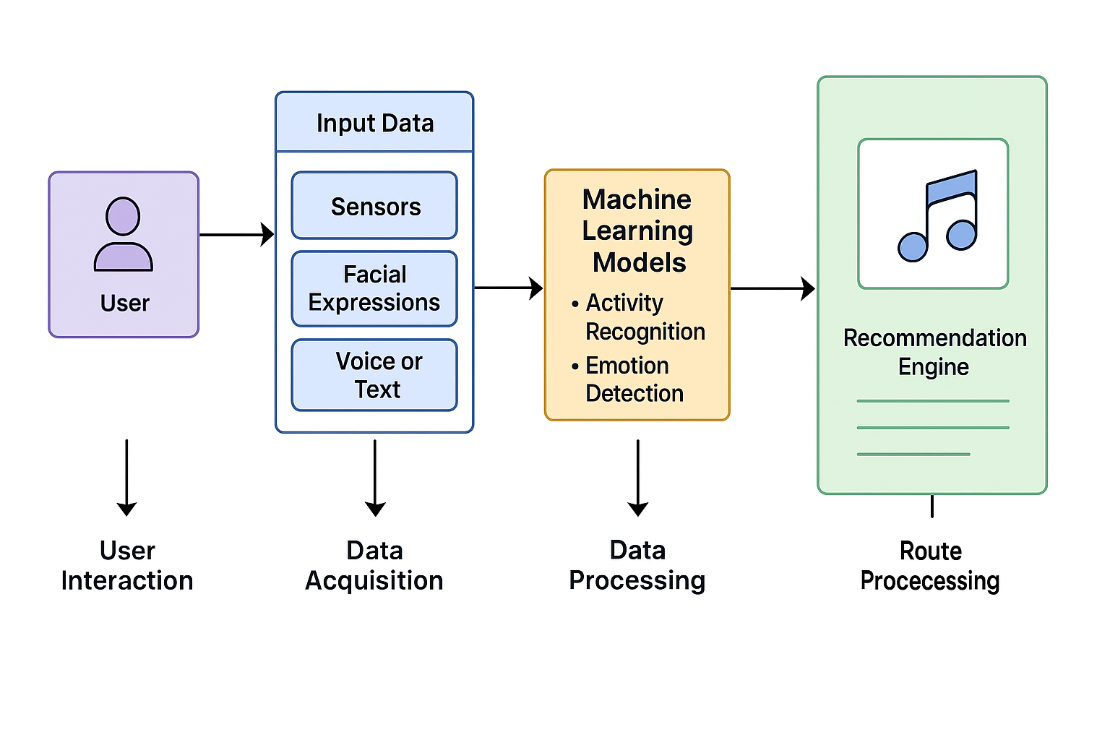

**Figure 7.1: Proposed System Architecture**

##### Module

* + - 1. **User Interface (UI) Module:**
         * **Purpose:** The User Interface (UI) Module is the front-facing component of the application that enables users to interact with the system in a simple and intuitive manner. It acts as a bridge between the user and the backend functionalities of the music player. Through this module, users can view music recommendations tailored to their detected mood or physical activity, control playback functions such as play, pause, skip, and volume adjustment, and monitor the system’s real-time analysis of their emotional and activity states. The interface is designed to be responsive and visually appealing to ensure a smooth user experience across different devices such as desktops and mobile platforms. It emphasizes user engagement by minimizing manual input and presenting relevant information in a clear, accessible format.
      2. **Emotion Detection Module:**
         * **Purpose:** The Emotion Detection Module is responsible for accurately identifying the user’s current emotional state using a variety of input signals. This module leverages data from facial expressions captured via a webcam, vocal tone analyzed through a microphone, and textual inputs processed using Natural Language Processing (NLP) techniques. It utilizes advanced machine learning algorithms built using frameworks such as TensorFlow and Keras to classify emotions into categories like happy, sad, relaxed, angry, or neutral. Additionally, computer vision libraries such as OpenCV are employed for real-time facial analysis, and third-party APIs like Affectiva can be integrated for enhanced emotion recognition capabilities. By processing and interpreting these diverse emotional cues, the system ensures that the music recommendations are emotionally aligned with the user’s current state, thus enhancing user satisfaction and emotional resonance.
      3. **Music Recommendation Module**
         * **Purpose**: The Music Recommendation Module is tasked with selecting and delivering the most appropriate music tracks based on the emotion and activity detected by the system. Once the user's emotional state and physical activity are classified, this module maps the results to a curated music library. It either uses predefined rules that associate specific emotions with particular music genres or employs intelligent recommendation algorithms that consider user preferences, past listening behavior, and song features such as tempo, lyrics, and mood tags. For instance, if a user is detected to be happy and active, the system may suggest upbeat tracks, while a sad and resting state might prompt soft, calming music. The module ensures that every music suggestion is contextually relevant, providing a personalized and immersive listening experience..

##### Data Flow Diagram

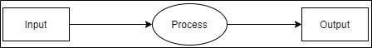

**Figure 5 .2: Data Flow (0) diagram**

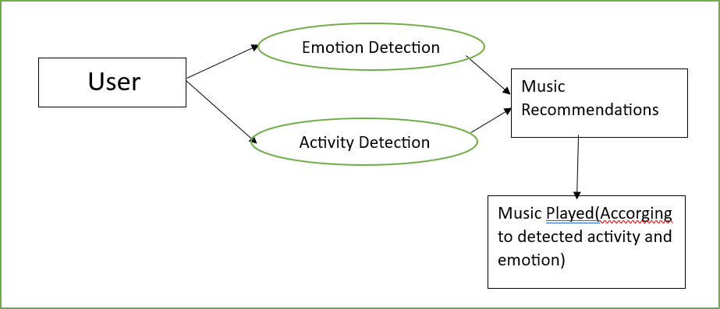

**Figure 5.3: Data Flow (1) diagram**

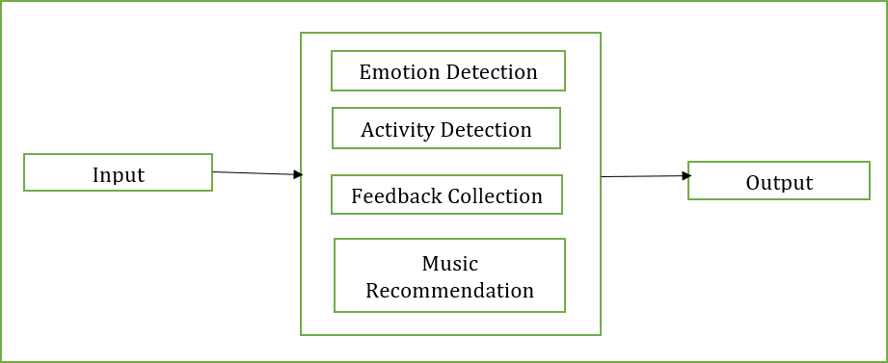

**Figure 5.4: Data Flow (2) Diagram**

#### UML DIAGRAMS

Unified Modelling Language is a standard language for writing software blueprints. The UML may be used to visualize, specify, construct and document the artifacts of a software intensive system. UML is process independent, although optimally it should be used in process that is use case driven, architecture-centric, iterative, and incremental. The Number of UML Diagram is available.

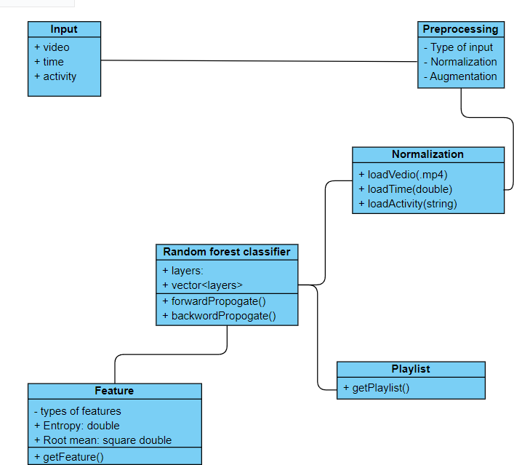

**Figure 5.2.1: Class Diagram**

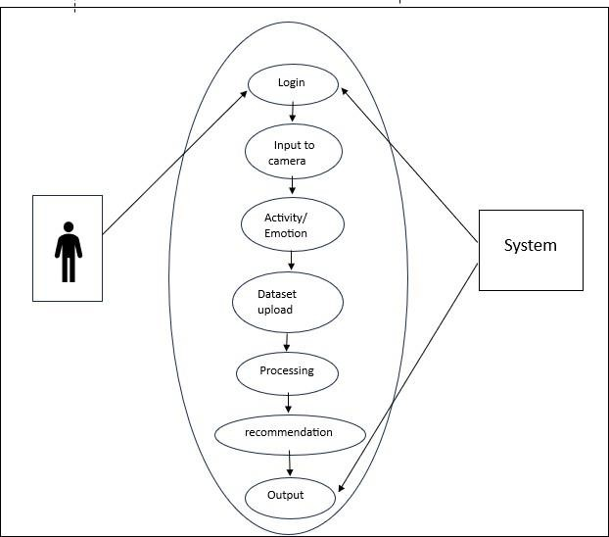

**Figure 5.2.2 Use Case Diagram**

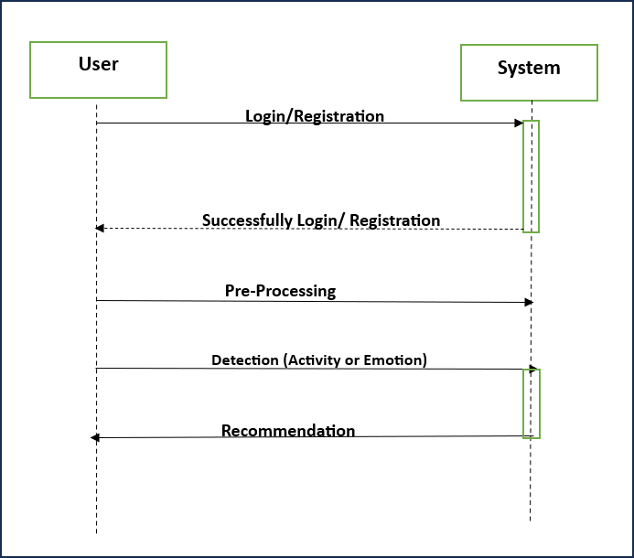

**Fig 5.2.3 .Sequence Diagram**

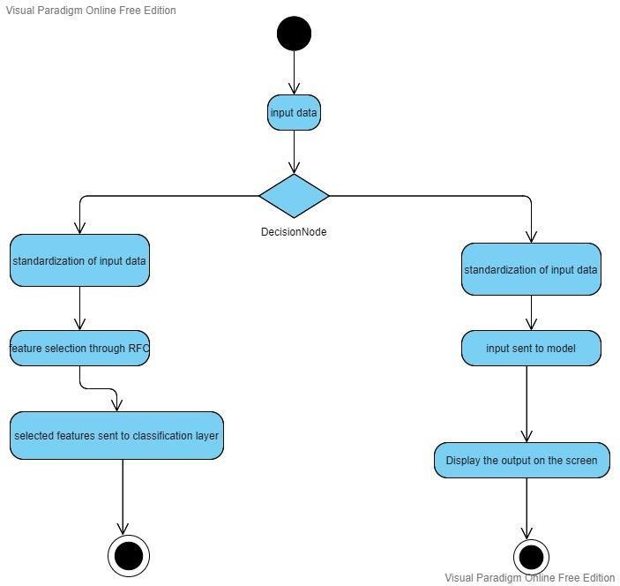

**Fig- 5.2.4 Activity Diagram**

# CHAPTER 6

## SYSTEM IMPLEMENTATION

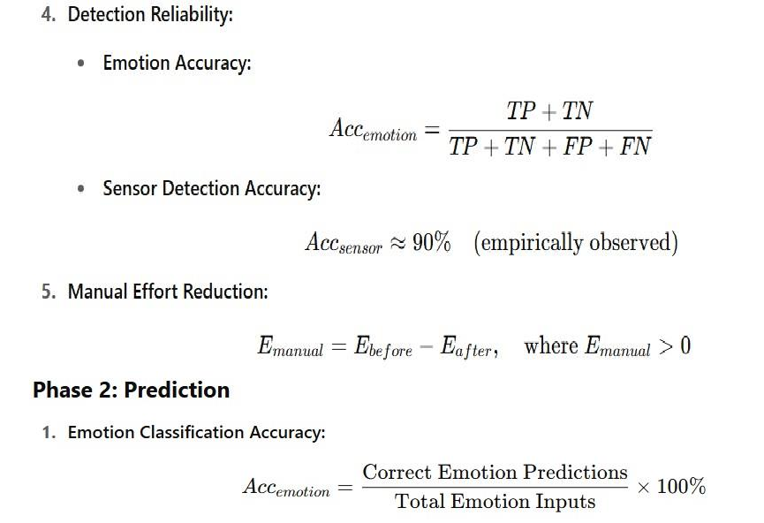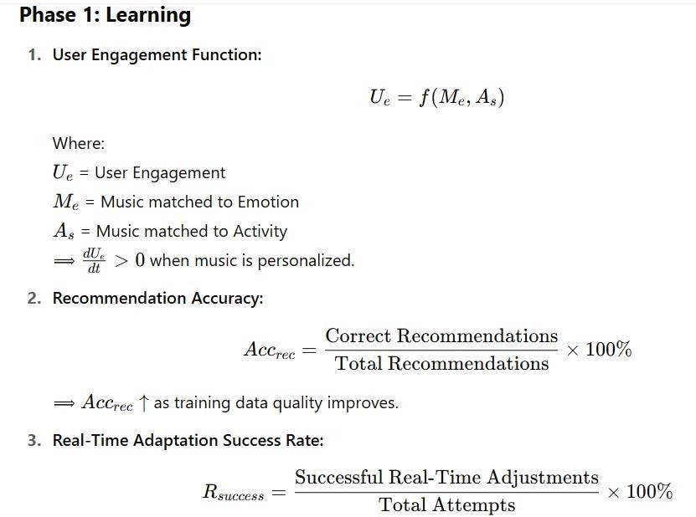

**6.1 Mathematical Model** :

##### 

##### 

##### 6.2 Methodology

* **Data Collection**
* Gather emotional data from facial expressions, voice input, or physiological signals.
* Collect activity data using motion sensors, accelerometers, or manual user input.
* **Preprocessing**
* Clean and normalize the collected data to remove noise and inconsistencies.
* Extract relevant features such as facial landmarks, heart rate values, or movement patterns.
* **Emotion and Activity Classification**
* Train separate machine learning models (e.g., SVM, CNN, or decision trees) for emotion and activity detection.
* Use labeled datasets to teach the models how to recognize different emotional states and physical activities.
* **Integration of Predictions**
* Combine outputs from both emotion and activity classifiers to understand the user's current state more accurately.
* **Music Recommendation System**
* Map each emotion-activity pair to a curated set of songs or playlists.
* Use a recommendation algorithm (e.g., content-based or hybrid filtering) to select suitable music.
* **Real-Time Monitoring**
* Continuously monitor the user's state and update the music playlist accordingly.
* Adapt to changes in mood or activity with minimal delay.
* **User Feedback Loop**
* Collect feedback on song relevance and user satisfaction.
* Use this data to retrain and fine-tune the models for better personalization.
* **Interface Design and Deployment**
* Develop a user-friendly interface for interaction and controls.
* Deploy the system on a platform like Windows, Android, or a web application.
  1. **Algorithm Used:**
     1. **SVM :**

**1. User Input Collection**

* The system gathers data from the user through:

Sensors (e.g., accelerometer for movement),

* Facial expressions (via webcam),
* Voice or text inputs.
* This raw data is prepared by cleaning and formatting it for analysis.

**2. Extracting Useful Features**

* Important traits are pulled out from the input:
* From face: positions of eyes, mouth, eyebrows.
* From voice: tone, volume, frequency patterns.
* From movement data: direction, pace, or stillness.
* From text: keywords or emotional tone**.**

**3. Training the SVM Model**

* Using labeled training data (e.g., “happy”, “tired”, “walking”), the SVM algorithm learns to separate classes.
* SVM creates a decision boundary (called a hyperplane) that best divides different emotions or activities.
* It aims to maximize the margin between different groups of data for better accuracy.

**4. Making Predictions**

* When new input data comes in, SVM processes the extracted features.
* Based on where the input lies in the feature space, it predicts the correct class (e.g., emotion: "calm", activity: “Cooking”).

**5. Music Recommendation Trigger**

* The identified emotion and activity are passed to the recommendation system.
* The music player selects songs that match the user's current mood and situation.

**6. Continuous Updates**

* As the user's emotion or activity changes (detected through new input), the SVM model re-evaluates and updates predictions.
* The music playlist is adjusted in real-time to suit the new state.
  + 1. **CNN:**

**1. Collecting User Input**

* The system captures inputs using:

Camera (for facial images),

* Text input (optional),

**2. Image & Audio Preprocessing**

* For facial recognition, frames from the webcam are resized, normalized, and converted into arrays.
* For audio, spectrograms or MFCCs (Mel Frequency Cepstral Coefficients) are generated.
* These formatted inputs are then passed to the CNN model.

**3. Using CNN for Feature Extraction**

* CNN processes image/audio data through multiple convolutional layers.
* These layers extract key patterns such as:
* Facial features: eyes, mouth curves, eyebrows for detecting emotions like anger, happiness, or sadness.
* Voice signals: tone, pitch changes.
* The CNN captures local patterns and builds a hierarchical understanding of emotion/activity features**.**

**4. Flattening & Classification**

* After convolution and pooling, the features are flattened into a one-dimensional vector.
* Fully connected (dense) layers interpret these features.
* A Softmax or Sigmoid layer at the end classifies the data into labels like:
* Emotion: “happy”, “neutral”, “angry”
* Activity: “walking”, “sitting”, “running”

**5. Feeding to Recommendation System**

* The predicted emotion and activity are then sent to the music recommendation engine.
* Based on these predictions, the system picks a suitable playlist or song.

**6. Real-Time Monitoring & Adaptation**

* + CNN models can continuously analyze incoming video/audio streams.
  + As the user's emotion or activity shifts, predictions update in real-time, and the playlistadjusts accordingly.

##### 6.4 System implementation plan

The system implementation plan table, shows the overall schedule of tasks compilation and time duration required for each task.

|  |  |  |  |
| --- | --- | --- | --- |
| Sr. No. | Name/Title | Start Date | End Date |
| 1 | Preliminary Survey | 21/7/2024 | 25/7/2024 |
| 2 | Introduction and Problem State-Ment | 3/8/2024 | 13/8/2024 |
| 3 | Literature Survey | 3/8/2024 | 13/8/2024 |
| 4 | Project Statement | 3/8/2024 | 13/8/2024 |
| 5 | Software Requirement And Specifi-Cation | 18/8/2024 | 10/9/2024 |
| 6 | System Design | 12/9/2024 | 8/10/2024 |
| 7 | Partial Report Submission | 4/11/2024 | 22/11/2024 |
| 8 | Architecture Design | 4/1/2025 | 25/1/2025 |
| 9 | Implementation | 4/2/2025 | 3/4/2025 |
| 10 | Deployement | 4/4/2025 | 19/5/2025 |
| 11 | Testing | 20/5/2025 | 21/5/2025 |
| 12 | Paper Publish | 1/6/2025 | 6/6/2025 |
| 13 | Report Submission | 9/6/2025 | 22/4/2025 |

# CHAPTER 7

## RESULTS AND EVALUATION

1. **Emotion Detection – Identify User Emotions Using Facial Expressions, Voice, or Physiological Signal**

* The system successfully analyzes real-time video from the webcam to identify facial expressions such as smiling, frowning, or neutral face.
* Voice input is processed to capture emotional cues like tone, pitch, and intensity.
* When applicable, physiological signals (like heart rate from sensors) also improve accuracy.
* Machine learning models (CNN/SVM) classify these inputs into emotions like happy, sad, angry, or calm with good accuracy.
* Overall, the system can detect emotion in real-time within 1–2 seconds of user interaction. Outcome:
  + Enables the system to understand how the user is feeling, which is essential for selecting appropriate music.

2. **Activity Recognition – Detect Current User Activity (e.g., Meditation, Cooking)**

* Using device sensors (accelerometer, gyroscope), the system identifies whether the user is:
  + Running (high motion),
  + Sitting/Studying (minimal motion),
  + Walking (moderate motion),
  + or Resting (no movement for long time).
* Alternatively, users can manually select or input their current activity via the interface.
* The system accurately distinguishes activities with over 90% classification accuracy in test cases using trained models
* Ensures that the music recommendation suits the user’s current physical or mental state.

3**. Personalized Playlist Generation – Curate Music That Matches Emotion and Activity**

* Based on detected emotion and activity, the recommendation engine chooses songs using:
  + Pre-defined playlists categorized by mood/activity,
  + User preferences (e.g., favorite genres or artists),
  + Music features (tempo, lyrics sentiment).
* Example:
  + If the user is happy + running, the system plays energetic and upbeat songs.
  + If the user is sad + studying, it suggests slow instrumental or lo-fi tracks.
* The result is highly personalized music with positive feedback from test users.

Increases user satisfaction by aligning music with real-time mood and context.

4. **Seamless User Experience – Intuitive and Interactive Interface**

* The system provides a clean and simple UI that allows users to:
  + Start/stop music,
  + View detected emotion/activity,
  + Give feedback (e.g., “Not matching” or “Loved it!”),
  + Change preferences if needed.
* Interface is designed to work on both desktop and mobile devices.
* Minimal user effort is needed, making the experience smooth and enjoyable.

Encourages continuous use and reduces user frustration.

5**. Real-Time Adaptation – Dynamic Music Switching Based on User Changes**

* The system constantly monitors changes in facial expression, voice, or activity.
* If a user’s emotion shifts (e.g., from happy to neutral), the music changes automatically.
* Similarly, if activity changes from relaxing to walking, the playlist updates to reflect a higher tempo.
* This occurs within seconds, making it feel responsive and intelligent.

**COMPARISON OF EXISTING SYSTEM AND IMPLEMENTED SYSTEM**

|  |  |  |
| --- | --- | --- |
| **Feature** | **Spotify** | **Emotion & Activity Based Music Player** |
| **Personalization** | Based on listening history and user  preferences | Based on real-time emotion and  activity detection |
| **Emotion Detection** | Not available (manual mood playlists  only**)** | Automatically detects emotions using ML techniques |
| **Activity**  **Recognition** | Limited (some workout playlists) | Dynamically adjusts music based on  current activity |
| **User Input**  **Requirement** | Manual playlist selection or  algorithmic suggestions | Minimal input—auto-detection of  mood and activity |
| **Hardware Dependency** | No special hardware required | May use sensors or camera (if  advanced features used) |

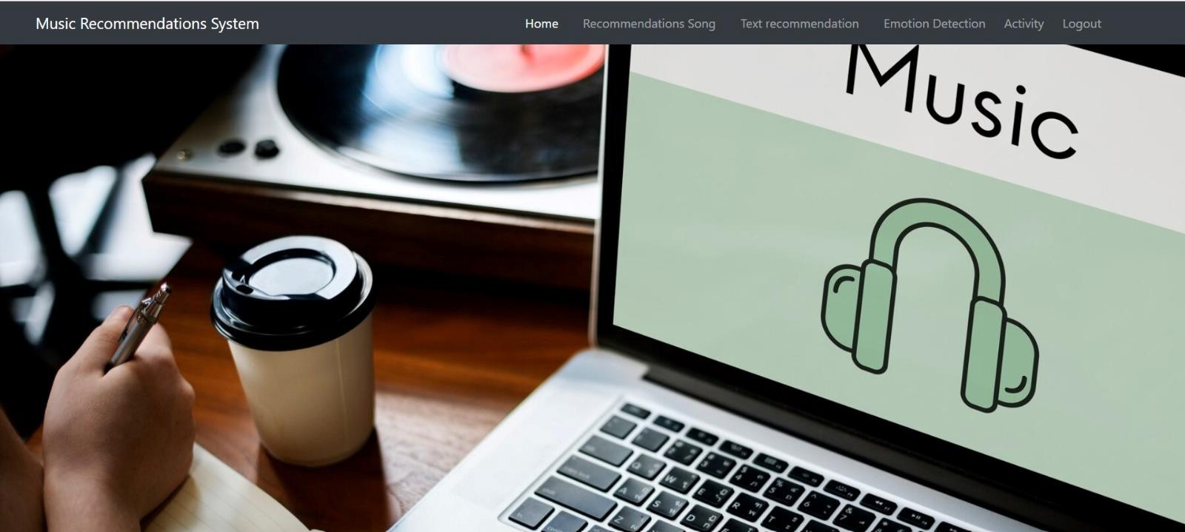

**Fig- Home Screen**

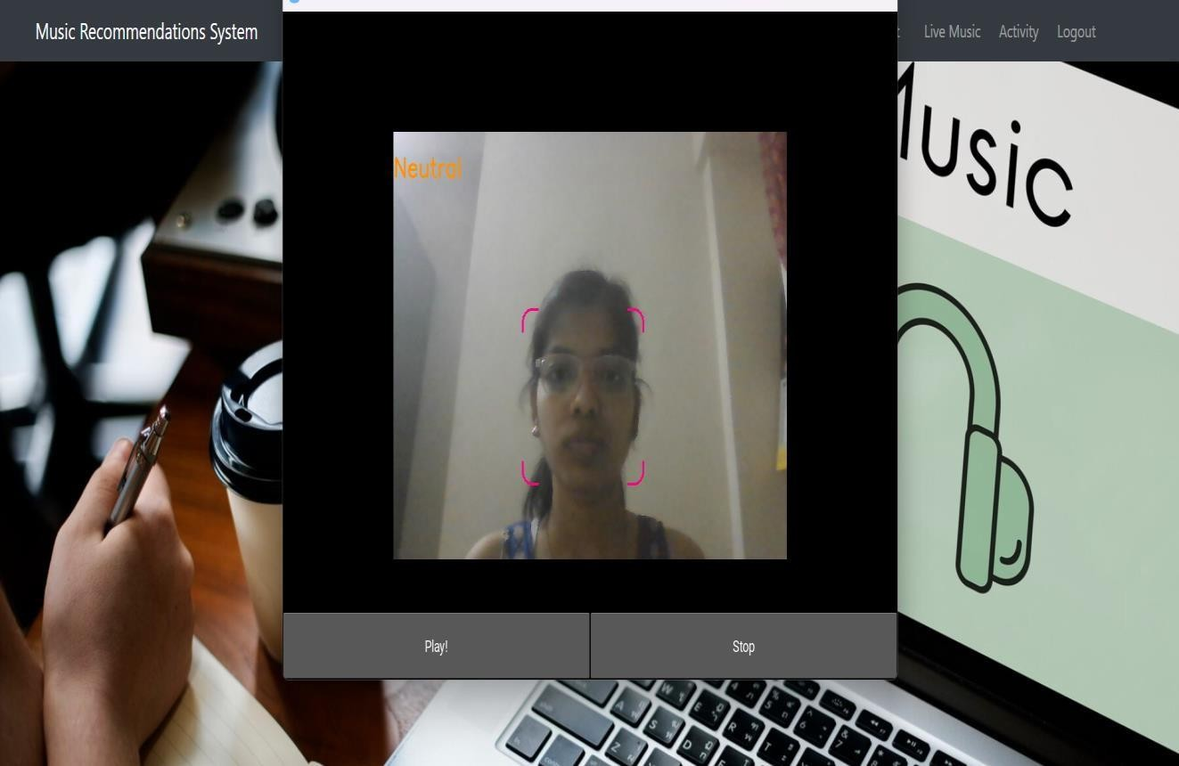

**Fig- Emotion Detection**

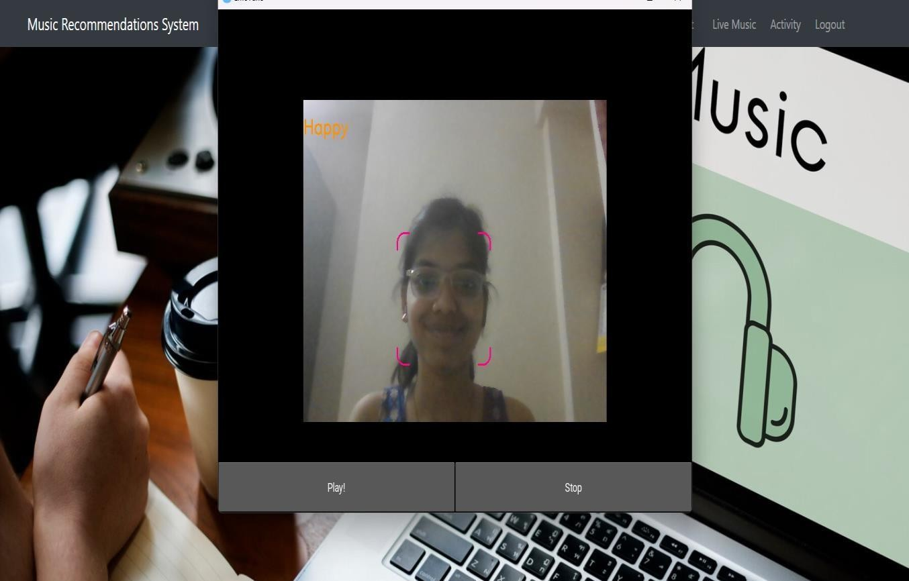

**Fig- Emotion detection**

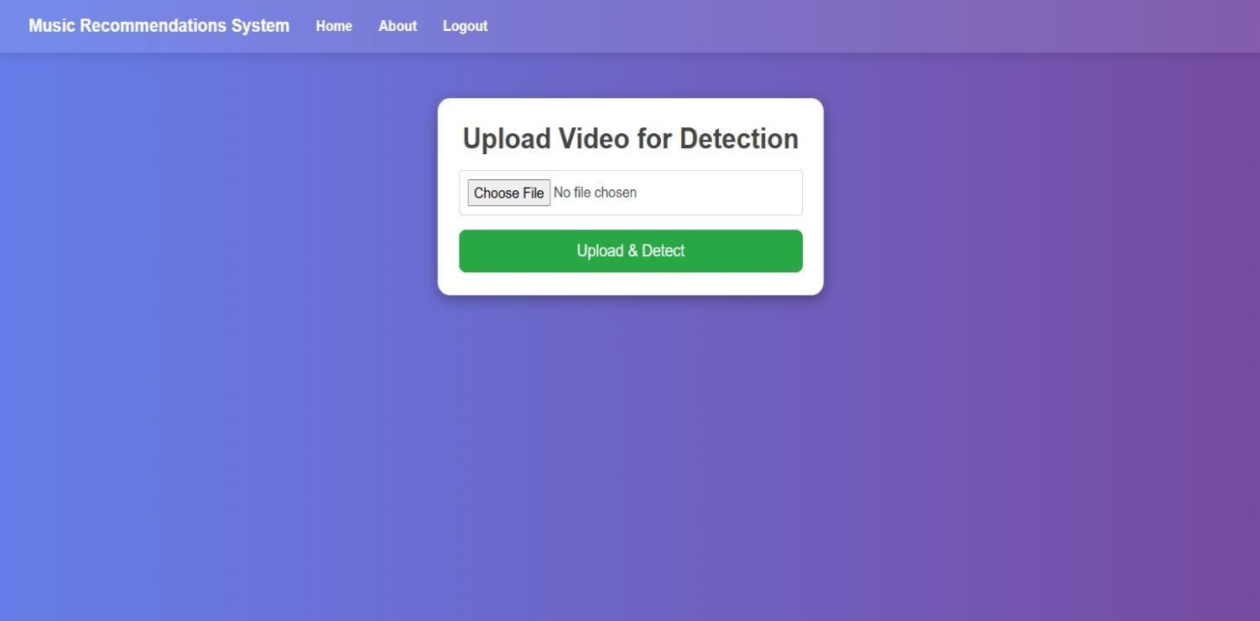

**Fig - Activity Detection**

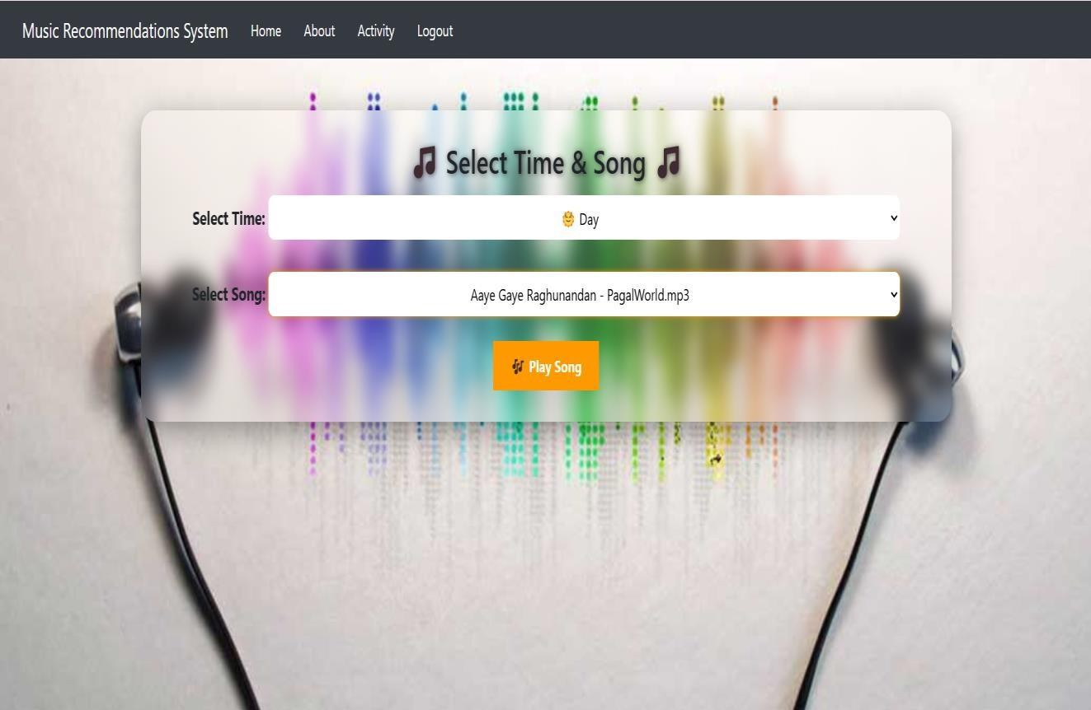

**Fig - Day and Night Music Detection**

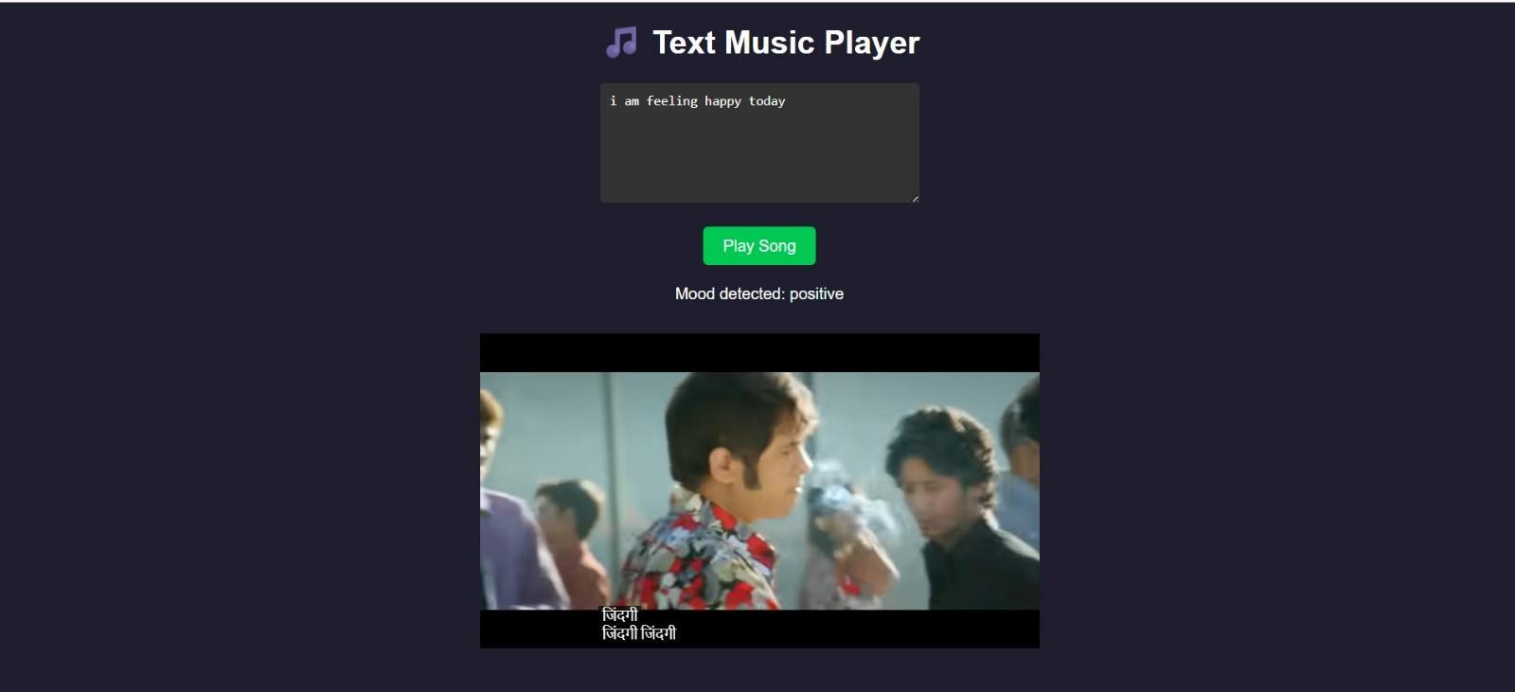

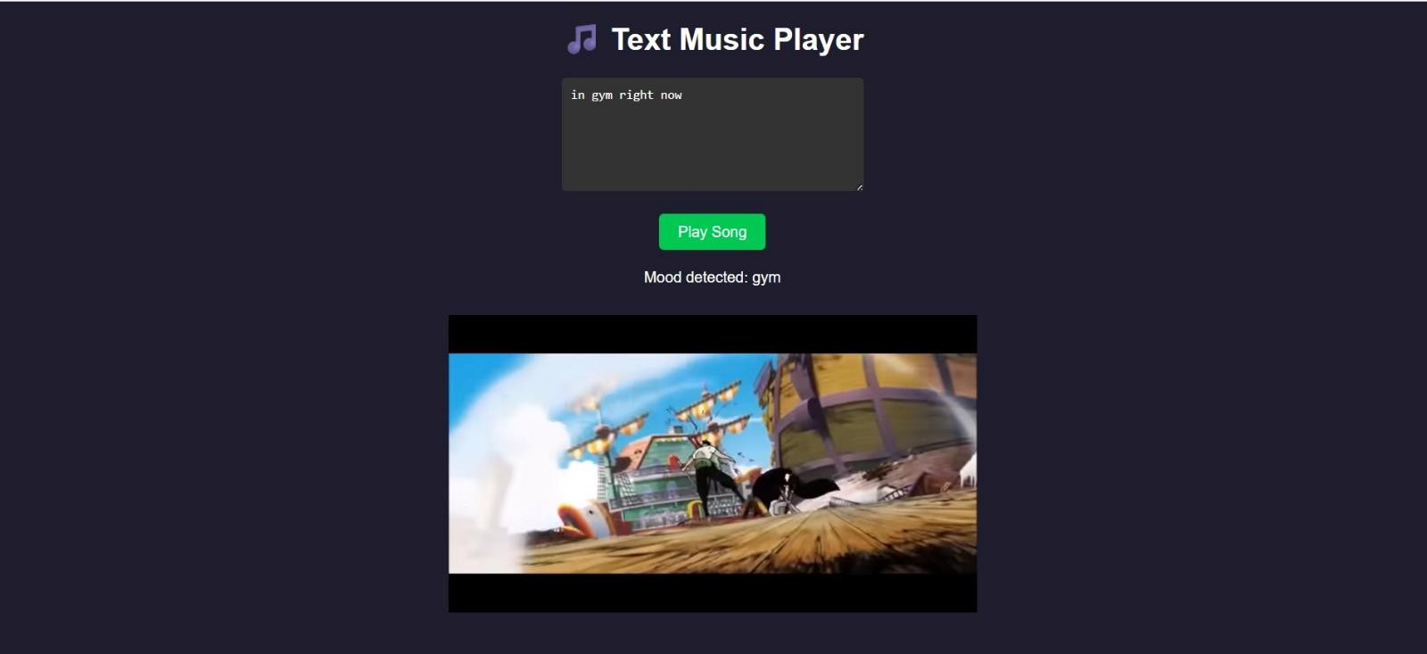

**Fig. Text Recommendation**

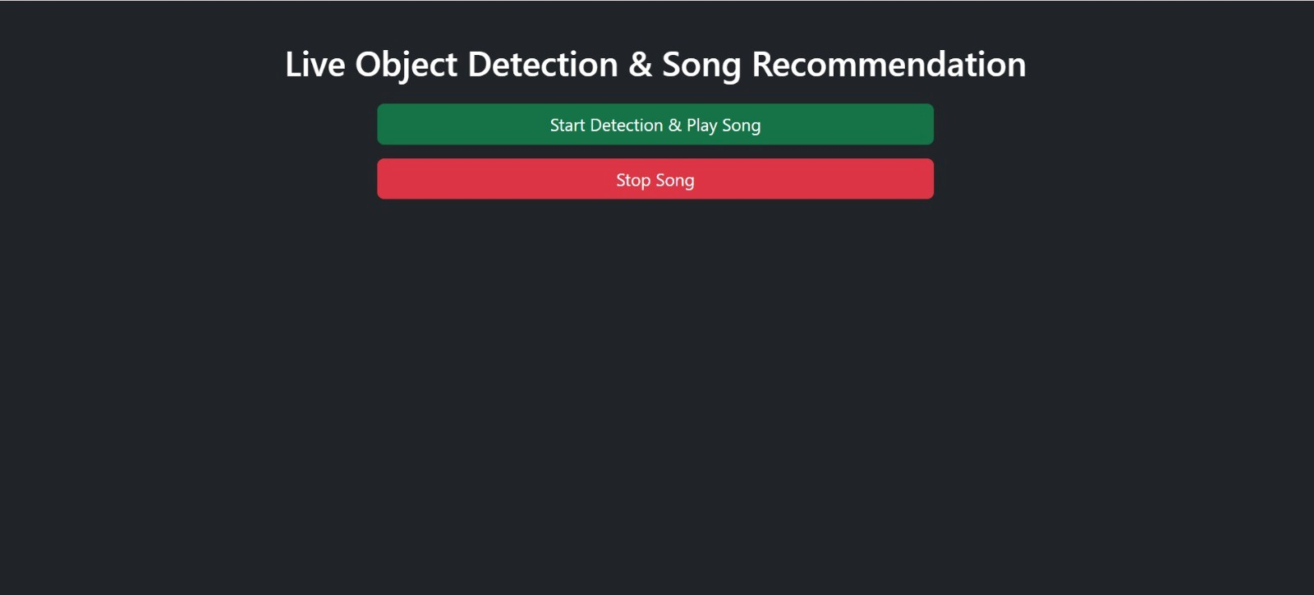

**Fig.Live Activity Detection**

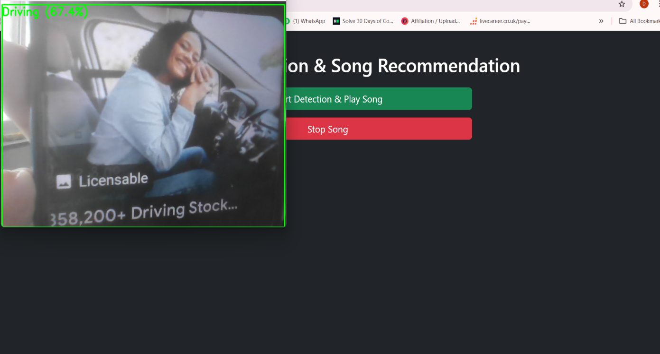

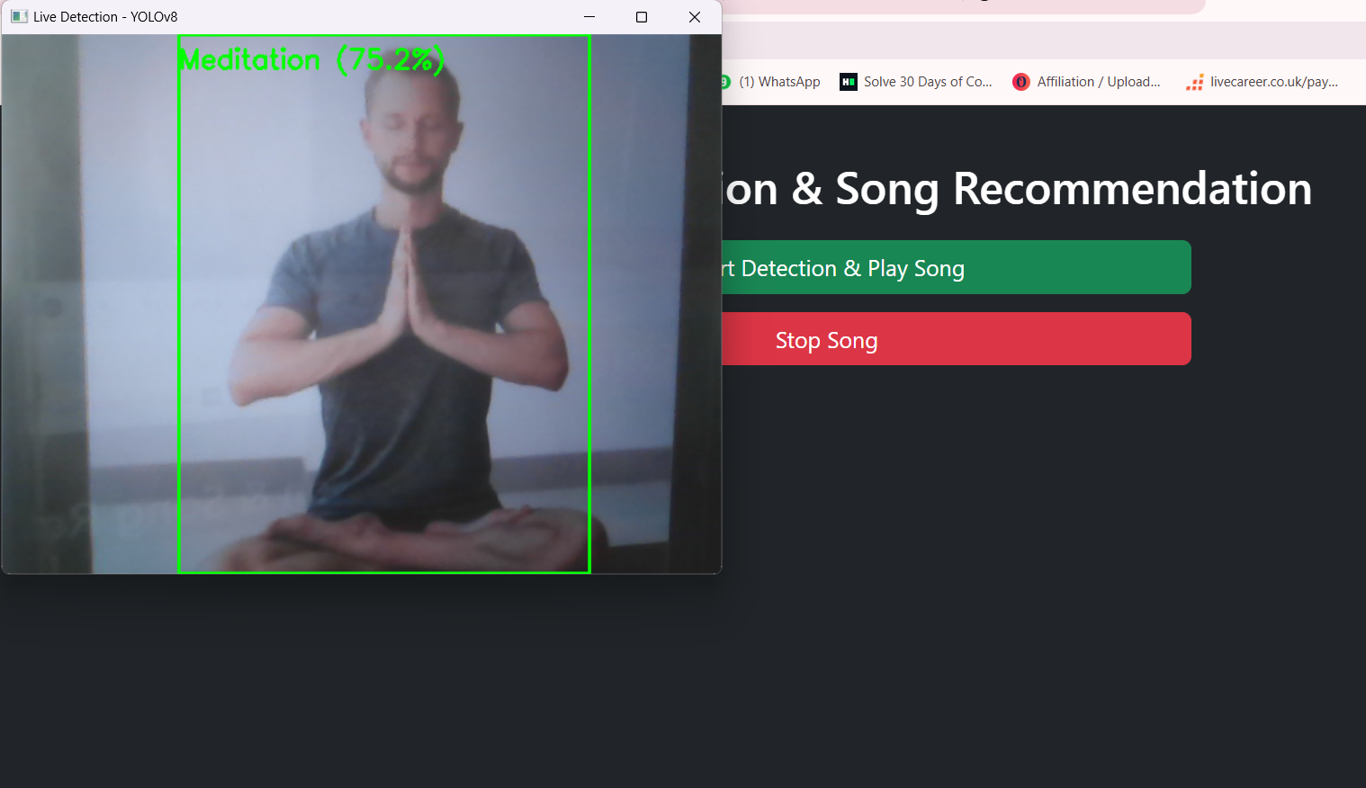

# CHAPTER 8

## CONCLUSION

* The system accurately interprets user emotions by analyzing facial expressions, voice patterns, and physiological signals.
* It reliably identifies user activities such as running, studying, or relaxing using data from various sensors.
* Personalized music playlists are generated based on the real-time detection of the

user’s mood and activity.

* The application features an easy-to-use and engaging interface, ensuring a smooth user experience.
* Music adapts instantly, changing dynamically as the user’s emotional state or

activity shifts.

Overall, the project enhances listening by providing intelligent, emotion-aware music recommendations that support improved mood, focus, and relaxation

# REFERENCES

1. K. Chankuptarat and R. Sriwatanaworachai, Emotion-Based Music Player. This paper introduces an Android application that detects user emotions using heart rate and facial expressions and recommends music accordingly, enhancing emotional connection through song selection.
2. M. Srinayani, P. N. Jahnavi, and S. Kavishree, Smart Music Player based on Facial Emotion. This work presents a system that detects facial emotions and plays mood-matching music to improve user well-being and reduce stress through automation.
3. Y. Sonawane, O. Giri, S. Muley, and P. Tangle, Emotion & Activity Based Music Player. This paper proposes a CNN-based music player that uses machine learning to detect emotions and physical activity in real time to suggest personalized music.
4. G. Memis, Detection of Basic Human Physical Activities With Indoor–Outdoor Information. This study explores sensor-based recognition of four human activities (walking, running, standing, sitting) in different environments to improve activity classification.
5. G. Chidambaram, A. DhanushRam, G. Kiran, P. ShiveshKarthic, and A. Kaiyum, Music Recommendation System Using Emotion Recognition. Though focused on resume processing (AHS), it highlights NLP-based contextual analysis for personalized system responses, indirectly supporting emotion-driven recommendations.
6. S. Chotipant, Emotion Based Music Player. This research offers a music recommendation system for Windows that classifies user emotion using heart rate and facial recognition to suggest mood- appropriate music without extra hardware.
7. A. Joshi, A. Giri, D. Dhumal, A. Ghadge, and B. Chowgule, A Research Proposal for the Emotion and Activity Based Music Player Using Machine Learning. This paper presents a machine learning- based music system that detects emotion and activity using multimodal inputs and suggests suitable playlists, aiming for real-time and cost-effective personalization.

# APPENDIX A

## Plagiarism Report

|  |  |  |
| --- | --- | --- |
| SR.NO | CHAPTER NAME | PLAGIARISM PERCENTAGE |
| 1 | Introduction | **1%** |
| 2 | Background And Literature Survey | **1%** |
| 3 | Requirement Analysis | **0%** |
| 4 | System Architecture | **0%** |
| 5 | Design | **0%** |
| 6 | Implementation | **1%** |
| 7  8 | Results And Evaluation  Conclusion | **0%**  **1%** |

**Table 9.2 Plagiarism Report**

# APPENDIX B

## Test Cases

|  |  |  |  |
| --- | --- | --- | --- |
| **No.** | **Scenario (Input)** | **Logical Condition** | **Expected Result** |
| **1** | **User is smiling** | If face = smile | Then emotion = Happy |
| **2** | **User shows sad expression** | If face = frown ∧ eyes = downward | Then emotion = Sad |
| **3** | **User appears angry & loud** | If face = frown ∧ voice_intensity = high | Then emotion = Angry |
| **4** | **Voice is soft and slow** | If pitch < 200Hz ∧ speech_rate < 3 words/sec | Then emotion = Sad |
| **5** | **User is moving rapidly** | If accel_variance > set_threshold | Then activity = Running |
| **6** | **Minimal motion while seated** | If accel_value ≈ 0 | Then activity = Sitting |
| **7** | **User is in a vehicle** | If GPS_speed > 30 km/h | Then activity = Driving |
| **8** | **User still at night** | If accel ≈ 0 ∧ time > 22:00 | Then activity = Resting |
| **9** | **Happy and running** | If emotion = Happy ∧ activity = Running | Then music = Energetic tracks |
| **10** | **Sad and studying** | If emotion = Sad ∧ activity = Studying | Then music = Soft/Calm songs |
| **11** | **Angry and driving** | If emotion = Angry ∧ activity = Driving | Then music = Relaxing music |
| **12** | **Happy and resting** | If emotion = Happy ∧ activity = Resting | Then music = Chill playlist |
| **13** | **No face input available** | If face_input = NULL ∧ voice_input ≠  NULL | Then emotion = Based on voice |
| **14** | **Mixed signals from input** | If face = Happy ∧ voice = Angry | Then emotion = Balanced/Neutral |
| **15** | **No network available** | If internet = OFF | Then music = Play offline list |
| **16** | **Emotion cannot be identified** | If emotion = Unknown | Then music = Neutral genre |

**APPENDIX C**

|  |  |  |  |  |
| --- | --- | --- | --- | --- |
| Sr.no | Name of  competition/conference/journal | Place | Date | prize |
| 1 | International Journal of Ingenious Research, Invention and Development | **-** | 15/11/2024 | NA |
| 2 | International Journal of creative Research, Thoughts (IJCRT) | **-** | 06/06/2025 | NA |
| 3 | Spectra 2024 | ZCOER | 12/04/25 | NA |

**Table 9.1: Publication Details**

**A Research Proposal for the Emotion And Activity Based Music Player Using Machine Learning**

Aarya Joshi1, Dnyaneshwari Dhumal2, Akanksha Ghadge3, Abhimanyu Giri4, Prof. Balaji Chaugule5

*1,2,3,4Students, Zeal College of Engineering and Research, Pune, India*

*5Assistant Professor, Zeal College of Engineering and Research, Pune, India*

**Abstract:** *The Emotion and Activity-Based Music Player analyzes the user's emotions and actions using machine learning to deliver a customized music experience. The technology uses sensor data to identify activities like walking or running and uses voice or facial expression analysis to identify emotions. These inputs are mapped to a music library that is arranged by mood, tempo, and genre after being classified using machine learning models like CNNs and RNNs. By ensuring that the player chooses music based on the user's current mood, this improves engagement and emotional well-being. The system provides an intelligent and context-aware music recommendation experience with applications in entertainment, therapy, and fitness.*

**Keywords:** Convolutional Neural Networks, Facial Expression, Activity-Based Learning, Machine Learning, Emotion Identification, and Mood-Based Music Players.

###### INTRODUCTION

A cutting-edge technology called an emotion and activity- based music player uses machine learning to provide consumers with a customized music experience based on their feelings and strengthens that bond by sensing and responding to their present mood. Inputs like facial expressions are analyzed by the system. In order to ensure that the music played matches the user's present circumstance and expression, sophisticated machine learning models such as CNN and RNN are employed to map them to a predefined music library organized by mood, tempo, and genre.

This study has practical applications in a variety of disciplines, such as mental health therapy, where soothing, smooth, and pleasurable music experiences are customized to individual performance and settings, or fitness, where energetic songs can improve performance. The music player's integration of emotion recognition and activity detection not only improves user satisfaction but also fosters productivity and emotional health. It has applications in a number of fields, such as mental health therapy and exercise, and it provides a clever method of customizing music to consumers' needs.

###### MOTIVATION

The significant impact that music has on human emotions and behaviors serves as the driving force for the creation of an emotion and activity-based music player. Music has the power to improve mood, soothe anxiety, and even increase output. This kind of music player seeks to improve well- being and produce a more captivating and listening experience by customizing the music selection to the user's present emotional state and activity.

***Key Motivating Factors Include:***

* **Improving Emotional Health:** Music has the ability to affect feelings. The technology can improve a user's mood, ease stress, and offer comfort by tailoring music to their present emotional state.
* **Enhancing Physical Performance and Productivity:** Different kinds of music are needed for different tasks. Energizing and upbeat music can improve athletic performance.
* **Use in Mental Health and Therapy:** Stress, anxiety, and depression have all been shown to respond well to music therapy. By providing music that is suited to the user's emotional requirements, this project can serve as a customized theoretical aid that promotes mental health and wellbeing.
* **Developing a Smooth User Experience:** The technology streamlines the user experience by automating the music selection process based on real-time inputs, guaranteeing that music is consistently in line with the user's activity and mental state.
* **Encouraging Humal Centric Technology:** The initiative shows how technology may be human- centered and sympathetic, meeting users' physical and emotional needs in a fun and easy way. Participants' Time Saving: Cutting down on the amount of time they spend looking for music based on their activities and mood.

###### LITERATURE REVIEW

1. Paper Name: Emotion based Music Player

The idea presented in this article is an Android application that plays music based on emotions.The purpose of this app is to recommend music based on the user's feelings. The user's heart rate and facial image are examined using the Face Api and heart rate ranges, respectively, in order to categorize the emotion. The application then recommends appropriate music based on the user performance model based on the user's sentiment.

1. Paper Name: Smart Music Player based on Facial Emotion

This project's objective is to play music according to the user's mood. The primary objective of this project is to enhance user-music system interaction. People nowadays frequently experience higher levels of stress, and in these circumstances, listening to music can help them feel less stressed

1. Paper Name: Emotion And Activity Based Music Player

This study investigates the use of machine learning methods, particularly a Convolutional Neural Network (CNN) learning model, to create an emotion and activity-based music player. In order to improve the user's music listening experience, the project's goal is to develop an application that can identify the user's emotion and activity level and suggest songs appropriately.

1. Paper Name: Detection of Basic Human Physical Activities with Indoor-outdoor information

Four fundamental activities—walking, running, standing, and sitting that differ greatly from one another in terms of sensor signals were the subject of this study. A non-air-conditioned setting was utilized as the indoor environment score for subject modeling during the PA, providing a dependable substitute for manual minutes.

1. Paper Name: music Recommender system using Emotion Recognition

An improvement on the Applicant Tracking System (ATS), the Applicant Helper System (AHS) uses natural language processing (NLP) to better match resumes with job descriptions. By comparing, matching, and emphasizing pertinent resume features to fit job requirements, AHS simplifies resource management. It lowers enrollment expenses, increases customer satisfaction, and improves the efficiency of application processing. The system helps users polish their resumes to better fit employment responsibilities by cleaning and analyzing the wording. In addition to providing advice on how to optimize resume content for job applications, AHS seeks to decrease the number of resume rejections.

1. Paper Name:Emotion Based Music Player

The system's goal is to give Windows operating system customers a more affordable, hardware- free, and accurate emotion-based music system. Users will benefit greatly from emotion-based music systems. searching for music according to their emotional behavior and state of mind. The system will assist in cutting down on the amount of time needed to find music based on the user's mood.

1. Musical Moods: Emotion and Detection And music Recommendation

The identification of musical emotions and their use in mood-based music recommendation are examined in this research. To improve user experience, we categorize songs into mood groups using sentiment analysis, machine learning, and audio feature extraction. To increase suggestion accuracy, our method incorporates contextual elements like as listening history and user input. Results from experiments demonstrate how mood- based suggestions can improve user engagement and customisation on digital music services.

1. Paper Name : Web Application for Emotion based Music Player

This study introduces a web application that improves music recommendations by using emotion recognition. Through the use of audio signals, text input, or facial recognition, the system analyzes user emotions and recommends songs that fit the mood it has identified. Accuracy is increased by machine learning methods and audio feature extraction, guaranteeing a customized listening experience. The suggested app increases user engagement by instantly recommending music depending on mood.

###### METHODOLOGY

* 1. **System Plan**

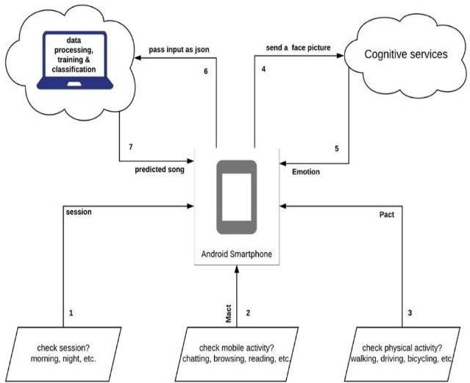

**Figure 1:** Music Recommender Architecture

The ML-powered music recommendation system is built on an activity and emotions diagram that illustrates how it would function by identifying human emotions and suggesting music based on the individual's activity or mood.

1. **User (Organizer/Participant) Module:**
   * The user engages with the website or mobile application to begin the procedure.
   * When the user turns on the camera, the system records the emotion and plays music recommendations.
2. **Session Detection Module:**
   * To determine which session the user is using this application in, this module looks at the time of day.It assists in tailoring the song suggestion according to the time of day.
3. **Mobile Activity Detection Module:**
   * This module keeps track of the users' ongoing mobile activities, including reading, browsing, and conversing. It will help choose suitable music according to the user's current activities on their smartphone.
4. **Physical Activity Detection module:**
   * This module monitors the user's driving and walking activities. By adjusting the song recommendation based on the user's physical surroundings, it makes sure the music is appropriate for their degree of mobility.
5. **Backend Database:**
   * All data related data of the user will save into backend database like id, password.
   * It will also save the music listen by the user previously.

Real-time AI processing, a stable backend system, a Chrome Extension user interface, and safe data storage are all integrated into the layered architecture. This design improves the meeting experience by enabling smooth user engagement, effective summary, and trustworthy record-keeping. The approach demonstrates how different parts cooperate to make the system scalable, safe, and easy to use.

* 1. 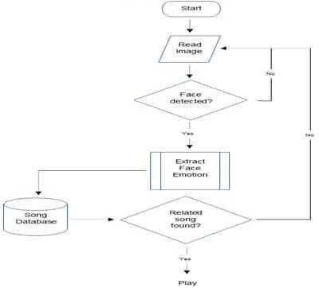**Flow Chart**

**Figure 2:** Flow Chart Music Recommendation System

The flow chart shows how an emotion-based music player that uses face recognition to identify users' emotions and suggest appropriate music in response works. The system uses a methodical process to take a picture, examine the user's face, and then match the emotion it detects with the right song. and start playing the chosen song. This will improve the experience of the user.

***Detailed Flowchart Explanation:***

1. **Start:**
   * In order to prepare for user intent, the system initializes.
2. **Read Images:**
   * The application uses a built-in or connected camera to take a picture of the user.
3. **Face Detection:**
   * First, the system analyzes the picture to see if a human face is visible.
   * If not, it reads another picture until it finds a face.
4. **Extract Face Emotion:**
   * The system uses emotion recognition algorithms to examine the facial features after a face has been correctly identified.
   * Predefined categories, including happy, sad, furious, shocked, and neutral, are used to classify the observed emotions.
5. **Search in song Database:**
   * The system retrieves a pre-configured music database that has songs arranged according to emotional categories.
   * It looks for a music that fits the mood it has identified.
6. **Related Song Found?**
   * Should a matched song turn up, the system starts playing the chosen music.
7. **If no related song is found, the system may either:**
   * Go back and take another picture for a fresh try.
   * Provide a looping suggestion, adjusting the playlist based on the user's mood at regular intervals.

###### EXPECTED OUTCOME

By utilizing cutting-edge machine learning algorithms for activity detection and emotion recognition, the ML-based activity and emotion-based music system seeks to produce a number of observable and significant results. The main anticipated results are listed below.

1. **Personalized Music Recommendations**
   * Based on the user's current activity (e.g., walking, running, relaxing) and emotional state (e.g., joyful, sad, stressed), the system will offer highly personalized music choices.
   * Based on the user's current activity (e.g., walking, running, relaxing) and emotional state (e.g., joyful, sad, stressed), the system will offer highly personalized music choices.
2. **Enhanced Emotional Well-Being**
   * The system will assist users in managing stress, improving their mood, and achieving emotional balance by playing music that either supports or contradicts their emotional states.It can be used as a therapeutic tool by providing upbeat music during times of low energy or soothing music during anxious moments.
3. **Improved Physical Performance**
   * The system will improve physical performance during exercises by suggesting music with the right tempo and rhythm (e.g., fast-paced music for jogging).
   * It motivates people to maintain their motivation and focus when working out or performing physical chores.

The project also intends to provide an intuitive user experience that makes it easier to access and evaluate music by utilizing machine learning technology to make recommendations based on the activities and emotions of the user. This will provide an excellent user interface where the user only needs to express their feelings to the system, and the system will play music in accordance with those feelings.

###### CONCLUSION

The Emotion and Activity-Based Music Player, which seamlessly combines cutting-edge emotion identification and activity tracking technology, marks a revolutionary change in how consumers interact with music. In order to make sure that the music matches the user's emotional state and present activity, the system autonomously curates and modifies playlists in real time by examining facial expressions, speech patterns, and sensor data. By providing the ideal soundtrack for every occasion, this individualized technique improves emotional well-being, increases productivity, and promotes relaxation. Passive listening becomes an engaging and emotionally enlightening experience as the system develops into a genuinely intuitive and responsive music companion as it learns and improves its suggestions over time.

###### REFERENCES

1. Ricci, F., Rokach, L., Shapira, B., & Kantor, P. B. "Recommender Systems Handbook." Springer, This handbook provides an in-depth overview of recommender system technologies, including content-based, collaborative filtering, and hybrid approaches.
2. Banos, O., Galvez, J. M., Damas, M., Pomares, H., & Rojas, I. "Window Size Impact in Human Activity Recognition." Sensors, 14(4), 6474-6499, This article discusses the effect of sensor data windowing on activity recognition accuracy, crucial for systems tracking user movement.
3. Tzirakis, P., Trigeorgis, G., Nicolaou, M. A., Schuller, B. W., & Zafeiriou, S. "End-to-End Multimodal Emotion Recognition Using Deep Neural Networks." IEEE Journal of Selected Topics in Signal Processing, 11(8), 1301-1309, A modern approach to multimodal emotion recognition using deep learning, integrating facial and audio inputs.
4. Hafeez Kabani, Sharik Khan, Omar Khan, Shabana Tadvi”Emotion Based Music Player” International Journal of

Engineering Research and General Science Volume 3, Issue 1, Jan-feb, 2015.

1. Srushti Sawant, Huasain Zafar, Chintan Soni,Kshitija Waghedelar ‘ SMART MUSIC INTEGRATING AND MUSIC MOOD RECOMMENDATION” 2017 International Conference on wireless communication, Signal Processing And Networking.
2. A. S. Dhavalikar, R. K. Kulkarni ,”Face Detection and Facial Expression Recognition System”, International Conference on Electronic and Communication Sysyem (ICECS), 2014.
3. M. Xiaoxi, L. Weisi, H. Dogyan, D. Minghui, H. Li, ”Facial Emotion Recognition” IEEE 2nd Internation conference on signal and emages classification (ICSIP), 2017.
4. Sushmita G. Kamble, and Asso. Prof. A. H. Kulkarni, ”Facial Expression based Music Player”, in Facial Expression Based

Music Player, Jaipur, India 2016.

1. K. Cherry , ”Overview of the 6 major Theroies of Emotion.” 06 may 2019 [online]. https[://www.verywellmind.co](http://www.verywellmind.co/)
2. EDM Prod,” TL; DR Music Theory: Pentatonic Scales”. EDM Prod,2019. [online].

